Performance issues and troubleshooting.

SCOPE
To check out the performance of Database and its Database server.
Find out possibilities to upgrade the system and performance.

RESPONSIBILITIES
Level 2 and Level 3 Engineers

Performance depends on the query executed, time taken by the query to completes its execution , temp db , indexing and rebuilding.
Performance Issues:-
Tempdb Full :-

Step1 : Check if any transaction runningand it is taking more time than
Expected (command dbcc opentran(tempdb)
Step 2 : See auto grow size is mentioned correctly.
Step 3:execute query and find the 100 topmost space used by specific SPID.
Step 4: if its production environment can’t able to restart SQL Server instance then use
Query DBCC FREESYSTEMCACHE ('ALL') with the DB owners approval.

Step 5: Try to shrink temp db if possible.
Step 6 : above all criteria did not works then take approval and restart SQL services.

Log File full issue:-
- Log File full issue comes in picture due to continues transactions and slow running
SQL queries.
- Go to database right click and shrink log file and try to release space.
- With the simple query DBCC SQLPERF(LOGSPACE) find the available and used Transaction space.
- Change activity performed after office hours with downtime can be carried out
by changing Database recovery model to Simple so that unnecessary log doesn’t
Occupy space in the LOG FILE.

Here, two options can be used to shrink the log file:

- Shrinking of Log File by using SQL Server Management Studio or SSMS
- Shrink the transaction log file by using T-SQL

In the above-mentioned option, SSMS is a server management tool that is easier to use can instantly reduce or shrink the size of log files. Here the database for which the shrink operation has to be performed can be chosen and by the right-clicking on it Shrink operation can be performed as shown in the following figure:

Shrinking through SSMS
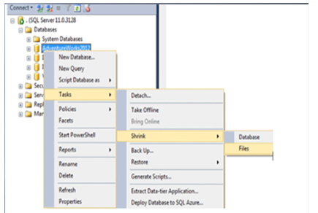

Here in this tool, you may have to choose the file type as log:
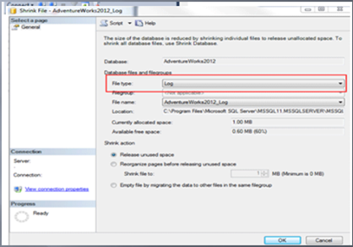

Thanking You.

